**ABSTRACT**

The cryptocurrencies, such as Bitcoin, are a form of digital currency designed to work outside of the traditional banking ecosystem. Cryptocurrencies are decentralized currencies that use blockchain technology to record transactions. Cryptocurrency transactions, aka the buying and selling of digital currency, are typically handled using a crypto-exchange platform. These transactions often involve large sums of cryptocurrency, typically anonymized utilizing the blockchain, hence attracting cybercriminals. Like any system, cryptocurrency platforms and exchange mechanisms are vulnerable to cyberattacks. Proliferation of cryptocurrencies (e.g., Bitcoin) that allow pseudo-anonymous transactions, has made it easier for ransomware developers to demand ransom by encrypting sensitive user data. The recently revealed strikes of ransomware attacks have already resulted in significant economic losses and societal harm across different sectors, ranging from local governments to health care. Most modern ransomware use Bitcoin for payments. However, although Bitcoin transactions are permanently recorded and publicly available, current approaches for detecting ransomware depend only on a couple of heuristics and/or tedious information gathering steps (e.g., running ransomware to collect ransomware related Bitcoin addresses). The proposed work undergoes four machine learning algorithms namely Logistic Regression, Random Forest Classifier, XG Boost Classifier and Voting Classifier among which XG Boost Classifier gives the maximum accuracy of 91.34%.

**LIST OF TABLES**

| **TABLE NO.** | **NAME OF THE TABLE** | **PAGE NO.** |
| --- | --- | --- |
| 4.1 | Data Dictionary | 24 |
| 7.1 | Classification Report of Logistic Regression | 46 |
| 7.2 | Classification Report of Random Forest Classifier | 46 |
| 7.3 | Classification Report of XG Boost Classifier | 47 |
| 7.4 | Classification Report of Voting Classifier | 47 |
| 7.5 | Confusion Matrix of Logistic Regression | 48 |
| 7.6 | Confusion Matrix of Random Forest Classifier | 48 |
| 7.7 | Confusion Matrix of XG Boost Classifier | 49 |
| 7.8 | Confusion Matrix of Voting Classifier | 49 |
| A.1 | Sample Dataset | 54 |

|  | **LIST OF FIGURES** |  |
| --- | --- | --- |
| **FIGURE NO.** | **NAME OF THE FIGURE** | **PAGE NO.** |
| 3.1 | Process of workflow diagram | 16 |
| 4.1 | Data Flow Diagram – Level 0 | 25 |
| 4.2 | Data Flow Diagram – Level 1 | 25 |
| 4.3 | Data Flow Diagram – Level 2 | 26 |
| 4.4 | Use Case Diagram | 27 |
| 4.5 | Sequence Diagram | 28 |
| 4.6 | Activity Diagram | 29 |
| 5.1 | System Architecture | 31 |
| 6.1 | Flow of Data Pre-processing | 33 |
| 6.2 | Screenshot of Analysis of Data | 35 |
| 6.3 | Screenshot of Unique Data Categorization | 35 |
| 6.4 | Flow of Data Visualization | 36 |
| 6.5 | Screenshot of Yearwise Count | 37 |
| 6.6 | Screenshot of piechart based on Label | 38 |
| 6.7 | Screenshot of piechart based on Year | 38 |
| 6.8 | Screenshot of Heatmap Plot Diagram | 39 |
| 6.9 | Screenshot of Density Plot on Attacks | 39 |
| 6.10 | Flow of Logistic Regression | 41 |
| 6.11 | Flow of Random Forest Classifier | 41 |
| 6.12 | Flow of XG Boost Classifier | 42 |
| 7.1 | Screenshot of Plot of Logistic Regression | 48 |
| 7.2 | Screenshot of Plot of Random Forest | 48 |
| 7.3 | Screenshot of Plot of XG Boost Classifier | 49 |
| 7.4 | Screenshot of Plot of Voting Classifier | 49 |
| A.1 | Deployment using Flask (Web Framework) | 69 |
| A.2 | Input Webpage | 69 |
| A.3 | Predicted Attack - Montreal CryptoXXX | 70 |
| A.4 | Predicted Attack - Montreal CryptoLocker | 70 |
| A.5 | Predicted Attack - CryptoWall | 71 |
| A.6 | Predicted Attack - Princeton Cerber | 71 |
| A.7 | Predicted Attack - Princeton Locky | 72 |
| A.8 | Predicted Attack - White | 72 |

**LIST OF ABBREVIATIONS**

|  |  |
| --- | --- |
| API | Application Programming Interface |
| GUI | Graphical User Interface |
| GPU | Graphics Processing Unit |
| CPU | Central Processing Unit |
| RAM | Random Access Memory |
| SVC | Support Vector Classifier |
| PyPI | Python Package Index |
| IPyNB | IPython Notebook |
| IoT | Internet of Things |
| ML | Machine Learning |
| DFD | Data Flow Diagram |
| UML | Unified Modeling Language |
| LR | Logistic Regression |
| RF | Random Forest |
| XG | Extreme Gradient |

**TABLE OF CONTENTS**

|  |  |  |
| --- | --- | --- |
| **CHAPTER NO.** | **TITLE** | **PAGE NO.** |
|  | **ABSTRACT** | v |
|  | **LIST OF TABLES** | vi |
|  | **LIST OF FIGURES** | vii |
|  | **LIST OF ABBREVIATIONS** | ix |
| **1.** | **INTRODUCTION** | 1 |
|  | 1.1 Overview | 2 |
|  | 1.2 Problem Definition | 3 |
| **2.** | **LITERATURE SURVEY** | 4 |
|  | 2.1 Introduction | 5 |
|  | 2.2 Literature Survey | 5 |
| **3.** | **SYSTEM ANALYSIS** | 12 |
|  | 3.1 Existing System | 13 |
|  | 3.2 Proposed System | 14 |
|  | 3.3 Feasibility Study | 14 |
|  | 3.3.1 Data Wrangling | 14 |
|  | 3.3.2 Data Collection | 15 |
|  | 3.3.3 Preprocessing | 15 |
|  | 3.3.4 Building the Classification Model | 15 |
|  | 3.3.5 Construction of a Predictive Model | 15 |
|  | 3.4 Hardware Environment | 16 |
|  | 3.5 Software Environment | 16 |
|  | 3.5.1 Software Description | 16 |
|  | 3.5.2 Anaconda Navigator | 17 |
|  | 3.5.3 Conda | 18 |
|  | 3.5.4 Jupyter Notebook | 19 |
|  | 3.5.5 Jupyter Notebook App | 21 |
| **4.** | **SYSTEM DESIGN** | 23 |
|  | 4.1 Data Dictionary | 24 |
|  | 4.2 Data Flow Diagram | 24 |
|  | 4.3 UML Diagrams | 26 |
|  | 4.3.1 Use Case Diagram | 26 |
|  | 4.3.2 Sequence Diagram | 27 |
|  | 4.3.3 Activity Diagram | 28 |
| **5.** | **SYSTEM ARCHITECTURE** | 30 |
|  | 5.1 System Architecture | 31 |
| **6.** | **SYSTEM IMPLEMENTATION** | 32 |
|  | 6.1 Module Design Specification | 33 |
|  | 6.1.1 Data Pre-processing | 33 |
|  | 6.1.2 Data Visualization | 36 |
|  | 6.2 Algorithm Implementation | 39 |
|  | 6.2.1 Logistic Regression | 40 |
|  | 6.2.2 Random Forest Classifier | 41 |
|  | 6.2.3 XG Boost Classifier | 42 |
|  | 6.2.4 Voting Classifier | 42 |
| **7.** | **PERFORMANCE ANALYSIS** | 43 |
|  | 7.1 Performance Metrics | 44 |
|  | 7.2 Classification Report of Algorithms | 46 |
|  | 7.3 Confusion Matrix Plot | 47 |
|  | 7.4 Results and Discussion | 50 |
| **8.** | **CONCLUSION** | 51 |
|  | 8.1 Conclusion and Future Enhancements | 52 |
|  | **APPENDICES** | 53 |
|  | A.1 Sample Dataset | 53 |
|  | A.2 Sample Coding | 55 |
|  | A.2.1 Server side coding | 55 |
|  | A.2.2 Client side coding | 67 |
|  | A.3 Sample Screens | 69 |
|  | **REFERENCES** | 73 |

**CHAPTER 1**

**INTRODUCTION**

**CHAPTER 1**

**INTRODUCTION**

* 1. **Overview**

Ransomware attacks are emerging as a major source of malware intrusion in recent times. Among the malicious usage of cryptocurrencies, ransomware payments continue to attract an ever increasing attention. Although encrypting files and resources for ransom has a long history, receiving ransom payments securely had never been simple until the emergence of Bitcoin. Proliferation of cryptocurrencies (e.g., Bitcoin) that allow pseudo-anonymous transactions, has made it easier for ran software developers to demand ransom by encrypting sensitive user data.

The recently revealed strikes of ransomware attacks have already resulted in significant economic losses and societal harm across different sectors, ranging from local governments to health care. Most modern ransomware use Bitcoin for payments. However, although Bitcoin transactions are permanently recorded and publicly available, current approaches for detecting ransomware depend only on a couple of heuristics and/or tedious information gathering steps (e.g., running ransomware to collect ransomware related Bitcoin addresses). Bitcoin transactions can be created anonymously, and participation in the network does not require identity verification. A payment can be requested by delivering a public Bitcoin address (i.e., a short string) to a sender by using anonymity networks.

The pseudo-anonymity of cryptocurrencies has attracted the interest of a diverse body of criminals, transnational terrorist groups, and illicit users. While so far ransomware has affected general-purpose adequately resourceful computing systems. Many ransomware prediction techniques are proposed but there is a need for more suitable ransomware prediction techniques for machine learning techniques. The application of the data science process is applied for getting a better model for predicting the outcome. Variable identification and data understanding is the main process of building a successful model. Different machine learning algorithms are applied to the pre-processed data and the accuracy is compared to see which algorithm performed better other performance metrics like precision, recall, f1-score are also taken in consideration for evaluating the model. The machine learning model is used to predict the ransomware attack outcome.

**1.2 Problem Definition**

The systems proposed until now implies that the previous approaches have not employed advanced Data Analytics techniques to automatically detect ransomware related transactions and malicious bitcoin addresses. By applying different models to each domain, accuracy is found. By doing this, we can predict which model will give a higher accuracy rate. The systems also did not attempt to predict the ransomware attacks into the class of the families. So, our project is to build a model which will be able to predict those types of ransomware attacks. This will prevent them from restricting access to infected computers by encrypting its contents and take actions for primary defenses.

**CHAPTER 2**

**LITERATURE SURVEY**

**CHAPTER 2**

**LITERATURE SURVEY**

**2.1 Introduction**

Most modern ransomware use Bitcoin for payments. However, although Bitcoin transactions are permanently recorded and publicly available, current approaches for detecting ransomware depend only on a couple of heuristics and/or tedious information gathering steps (e.g., running ransomware to collect ransomware related Bitcoin addresses). To our knowledge, none of the previous approaches have employed advanced data analytics techniques to automatically detect ransomware related transactions and malicious Bitcoin addresses. By capitalizing on the recent advances in topological data analysis, we propose an efficient and tractable data analytics framework to automatically detect new malicious addresses in a ransomware family, given only a limited records of previous transactions. Furthermore, our proposed techniques exhibit high utility to detect the emergence of new ransomware families, that is, ransomware with no previous records of transactions. Using the existing known ransomware data sets, we show that our proposed methodology provides significant improvements in precision and recall for ransomware transaction detection, compared to existing heuristic based approaches, and can be utilized to automate ransomware detection.

**2.2 Literature Survey**

**[1] On Ransomware Family Attribution Using Pre-Attack Paranoia Activities**

**Author(s):** Ricardo Misael Ayala Molina, Sadegh Torabi, Khaled Sarieddine, Elias Bou-Harb, Nizar Bouguila, Chadi Assi

**Year:** 2022

**Description:** Ransomware attacks are among the most disruptive cyber threats, causing significant financial losses while impacting productivity, accessibility, and reputation. Despite their end goals (encryption/locking), ransomware are often designed to evade detection by executing a series of pre-attack API calls, namely “paranoia” activities, for determining a suitable execution environment. In this work, a first-of-a-kind effort to utilize such paranoia activities for characterizing ransomware distinguishable behaviours is presented.

**[2] Machine Learning-Based Ransomware Classification of Bitcoin Transactions**

**Author(s):** Suleiman Ali Alsaif

**Year:** 2022

**Description:** Ransomware attacks are one of the most dangerous related crimes in the coin market. To increase the challenge of fighting the attack, early detection of ransomware seems necessary. The proposed approach makes use of three supervised machine learning methods to learn the distinctive patterns in Bitcoin payment transactions, namely, logistic regression (LR), random forest (RF), and Extreme Gradient Boosting (XG Boost). These ML-based predictive models on the BitcoinHeist ransomware dataset in terms of classification accuracy and other evaluation measures such as confusion matrix, recall, and *F*1-score.

**[3]** **An economic analysis of ransomware and its welfare consequences**

**Author(s):** J. Hernandez-Castro, A. Cartwright and E. Cartwright

**Year:** 2022

**Description:** In this work an economic analysis of ransomware, a relatively new form of cyber-enabled extortion is presented. The illegal gains of the criminals will depend on the strategies they use, examining uniform pricing and price discrimination. In addition, the results of a pilot survey which demonstrate proof of concept in evaluating the costs of ransomware attacks is also presented. The different strategies analysed have been encountered already in existing malware, and the likelihood of them being implemented in the future. This work will provide some useful insights for predicting how ransomware may evolve in the future.

**[4]** **Bitcoin Ransomware Detection Employing Rule-Based Algorithms**

**Author(s):** Hardi Sabah Talabani, Hezha M.TAREQ Abdulhadi

**Year:** 2022

**Description:** The Ransomware attack is a type of cybercrime and a class of malware that encrypts the files and prevents users from accessing their data or systems and demands payment for decrypting and retrieving access to their files. Ransomware data classification using present data mining and machine learning methods is difficult because predictions aren't always correct. This aims to build two models that effectively address these challenges and can diagnose and classify Ransomware attacks accurately, then compare the performance of the models. In this paper, the investigation of use of Rule-Based algorithms for mining Bitcoin Ransomware Data to classify Ransomware attacks in Bitcoin transactions, employing Rule-Based techniques in detecting Bitcoin data is beneficial because the algorithms effectively classify non-linear datasets.

**[5]** **A Survey of Crypto Ransomware Attack Detection Methodologies: An Evolving Outlook**

**Author(s):** Abdullah Alqahtani, Frederick T. Sheldon

**Year:** 2022

**Description:**  Ransomware attacks have been among the major threats that target a wide range of Internet and mobile users throughout the world, especially critical cyber physical systems. The evasive mechanisms that these attacks employ to avoid detection often nullify the solutions that are currently in place. This survey is devoted to exploring and analyzing the state-of-the-art in ransomware attack detection toward facilitating the research community that endeavors to disrupt this very critical and escalating ransomware problem. The focus is on crypto ransomware as the most prevalent, destructive, and challenging variation.

**[6] A Survey on Detection and Classification of Ransomware Bitcoin Transactions**

**Author(s):** Sabira Karim, Shemitha PA

**Year:** 2021

**Description:** Ransomware transactions are widely used in crypto-currencies. Most modern ransomware use Bitcoin for payments. Based on the collected ransomware related Bitcoin addresses, the researchers have employed advanced data analytics techniques to detect ransomware related transactions and malicious Bitcoin addresses automatically. The machine learning approaches are evaluated based on the patterns differentiating such cybercrime operations from normal bit-coin transactions in order to identify and report attacks. This work would be the ultimate opportunity to expand and organize research efforts in future work by applying some early preventions and strategies to defeat these kinds of malicious transactions.

**[7]** **Predictive Analysis of Ransomware Attacks using Context-aware AI in IoT Systems**

**Author(s):** Vytarani Mathane, P.V. Lakshmi

**Year:** 2021

**Description:** Many ransomware prediction techniques are proposed but there is a need for more suitable ransomware prediction techniques for constrained heterogeneous IoT systems. Using attack context information profiles reduces the use of resources required by resource-constrained IoT systems. This paper presents a context-aware ransomware prediction technique that uses context ontology for extracting information features (connection requests, software updates, etc.) and Artificial Intelligence, Machine Learning algorithms for predicting ransomware. The proposed techniques focus and rely on early prediction and detection of ransomware penetration attempts to resource-constrained IoT systems.

**[8] The BitcoinHeist: Classifications of Ransomware Crime Families**

**Author(s):** Micheline Al Harrack

**Year:** 2021

**Description:** Ransomware attacks are on the rise and attackers are hijacking valuable information from different critical infrastructures and businesses requiring ransom payments to release the encrypted files. The different transactions features are analyzed to predict a classifier label among the classifiers that have been identified as ransomware or associated with malicious activity. Machine learning techniques are utilized to train the machine to recognize specific transactions and trace them back to malicious transactions or benign ones. This paper uses decision tree classifiers and ensemble learning to implement a random forest classifier.

**[9]** **Investigating Machine Learning Approaches for Bitcoin Ransomware Payment Detection System**

**Author(s):** Kirat Jadhav

**Year:** 2020

**Description:** Cryptocurrencies have revolutionized the process of trading in the digital world. Roughly one decade since the induction of the first bitcoin block, thousands of cryptocurrencies have been introduced. The anonymity offered by the cryptocurrencies also attracted the perpetuators of cybercrime. This paper attempts to examine the different machine learning approaches for efficiently identifying ransomware payments made to the operators using bitcoin transactions. Machine learning models may be developed based on patterns differentiating such cybercrime operations from normal bitcoin transactions in order to identify and report attacks. The machine learning approaches are evaluated on bitcoin ransomware dataset. Experimental results show that Gradient Boosting and XG Boost algorithms achieved better detection rate with respect to precision, recall and F-measure rates when compared with k-Nearest Neighbor, Random Forest, Naïve Bayes and Multilayer Perceptron approaches.

**[10] Individual Cyber Security: Empowering Employees to Resist Spear Phishing to Prevent Identity Theft and Ransomware Attacks**

**Author(s):** Jason E. Thomas

**Year:** 2018

**Description:** Phishing is a difficult problem to address because there are many permutations, messages, and value propositions that can be sent to targets. Spear phishing is also associated with social engineering, which can be difficult for even trained or savvy employees to detect. This makes the user the critical point of entry for miscreants seeking to perpetrate cyber crimes such as identity theft and ransomware propagation, which cause billions of dollars in losses each year. Researchers are exploring many avenues to address this problem, including educating users and making them aware of the repercussions of becoming victims of phishing. The purpose of this study was to interview security professionals to gain better insight on preventing users and employees from succumbing to phishing attack.

**[11] Behavioural Analysis of Recent Ransomwares and Prediction of Future Attacks by Polymorphic and Metamorphic Ransomware**

**Author(s):** Navneet Kaur Popli, Anup Girdhar

**Year:** 2018

**Description:** Attackers understand that data, files, networks and all digital resources are a key factor in the regular working and growth of any business. And because these digital resources are so dear to the business, the best and quickest way to earn big money is to hold all these resources at ransom.Ransomware is the biggest threat to enterprises and has the potential to bring business at standstill and cause huge loss to economy. In this paper, an analytical study of the behaviours of the recent ransomwares that have attacked businesses and individuals alike is done. This is done by running them in a simulated environment and analyse their attack process, file system analysis, persistence analysis and network-level analysis. Tools like Cuckoo is employed to do this behaviour analysis part. After that,prediction of the future types of ransomwares which can be created easily by using available toolkits like ADMMutate, Clet and Phatbot. Also predicting the impact and the threat they can cause and how difficult it would be to detect them after they employ all the mentioned stealth techniques.

**CHAPTER 3**

**SYSTEM ANALYSIS**

**CHAPTER 3**

**SYSTEM ANAYSIS**

**3.1 Existing System**

Ransomware attacks are among the most disruptive cyber threats, causing significant financial losses while impacting productivity, accessibility, and reputation. Despite their end goals (encryption/locking), ransomware are often designed to evade detection by executing a series of pre-attack API calls, namely “paranoia” activities, for determining a suitable execution environment. In this work, we present a first-of-a-kind effort to utilize such paranoia activities for characterizing ransomware distinguishable behaviors. To this end, we draw-upon more than 3K samples from recent/prominent ransomware families to fingerprint their uniquely leveraged paranoia activities. In this work, we propose a dynamic analysis approach for attributing ransomware samples based on their pre-attack paranoia activities. We execute more than 3,000 ransomware samples that belong to 5 predominant families in a sandboxing environment to collect their behavioral characteristics/features in terms of 23 selected pre-attack evasion API calls that are associated with sensing the execution environment.

**Disadvantages of Existing System**

1. The ransomware attacks predicted in the existing system were not mentioned with their kind which denotes their behavioural patterns.
2. The algorithms implemented other than random forest classfier could not give much accuracy as there wasn’t enough dataset.
3. The ransomware attacks recognised had class imbalances which couldn’t predict the patterns as much needed.

**3.2 Proposed System**

The proposed system is to build a model able to predict the types of ransomware attacks. The process starts with variable identification like dependent and independent variables where we find the target column. Then the pre-processing techniques are applied to deal with missing values the pre-processed data is then used to build a model by dividing the dataset into 7:3 ratios where 70% of the data is used for training purposes that are model learns the pattern and the remaining 30% testing data is used to test the performance of our project. The classification model can be used to predict the bitcoin heist ransomware attack types.

**Advantages of Proposed System**

1. The proposed system is implemented particularly based on bitcoin ransomware attack prediction.
2. The implementation of an algorithm known as the voting classifier is done for the identification of best classification results.
3. The dataset involves more than 14K sample of features which could give the best accuracy for attack prediction.
4. The deployment of ransomware attack prediction is done with necessary inputs and designed for the end users.

**3.3 Feasibility Study**

## **3.3.1 Data Wrangling**

## In this section of the report will load in the data, check for cleanliness, and then trim and clean given dataset for analysis. Make sure that the document steps carefully and justify for cleaning decisions.

**3.3.2 Data Collection**

The data set collected for predicting given data is split into Training set and Test set. Generally, 7:3 ratios are applied to split the Training set and Test set. The Data Model which was created using Random Forest, logistic, Decision tree algorithms, Support vector classifier (SVC), Multilayer Perceptron are applied on the Training set and based on the test result accuracy, Test set prediction is done.

**3.3.3 Preprocessing**

The data which was collected might contain missing values that may lead to inconsistency. To gain better results data need to be preprocessed so as to improve the efficiency of the algorithm. The outliers have to be removed and also variable conversion need to be done.

**3.3.4 Building the Classification Model**

The prediction of stellar classification, a high accuracy prediction model is effective because of the following reasons: It provides better results in classification problem.

* It is strong in preprocessing outliers, irrelevant variables, and a mix of continuous, categorical and discrete variables.
* It produces out of bag estimate error which has proven to be unbiased in many tests and it is relatively easy to tune with.

**3.3.5 Construction of a Predictive Model**

Machine learning needs data gathering have lot of past data’s. Data gathering have sufficient historical data and raw data. Before data pre-processing, raw data can’t be used directly. It’s used to pre-process then, what kind of algorithm with model. Training and testing this model working and predicting correctly with minimum errors. Tuned model involved by tuned time to time with improving the accuracy.

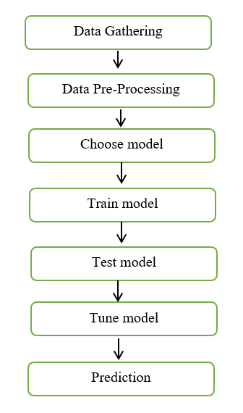

**Fig 3.1 Processs of workflow diagram**

**3.4 Hardware Environment**

Processor : Intel i3

Hard disk : minimum 80 GB

RAM : minimum 2 GB

**3.5 Software Environment**

Operating System : Windows 10 or later

Tool(s) : Anaconda with Jupyter Notebook

**3.5.1 Software Description**

Anaconda is a free and open-source distribution of the Python and R programming languages for scientific computing (data science, machine learning applications, large-scale data processing, predictive analytics, etc.), that aims to simplify package management and deployment. Package versions are managed by the package management system “Conda”. The Anaconda distribution is used by over 12 million users and includes more than 1400 popular data-science packages suitable for Windows, Linux, and MacOS. So, Anaconda distribution comes with more than 1,400 packages as well as the Conda package and virtual environment manager called Anaconda Navigator and it eliminates the need to learn to install each library independently. The open source packages can be individually installed from the Anaconda repository with the conda install command or using the pip install command that is installed with Anaconda. Pip packages provide many of the features of conda packages and in most cases they can work together. Custom packages can be made using the conda build command, and can be shared with others by uploading them to Anaconda Cloud, PyPI or other repositories. The default installation of Anaconda2 includes Python 2.7 and Anaconda3 includes Python 3.7. However, you can create new environments that include any version of Python packaged with conda.

**3.5.2 Anaconda Navigator**

Anaconda Navigator is a desktop graphical user interface (GUI) included in Anaconda® distribution that allows you to launch applications and easily manage conda packages, environments, and channels without using command-line commands. Navigator can search for packages on Anaconda.org or in a local Anaconda Repository. Now, if you are primarily doing data science work, Anaconda is also a great option. Anaconda is created by Continuum Analytics, and it is a Python distribution that comes preinstalled with lots of useful python libraries for data science.

Anaconda is a distribution of the Python and R programming languages for scientific computing (data science, machine learning applications, large-scale data processing, predictive analytics, etc.), that aims to simplify package management and deployment.

In order to run, many scientific packages depend on specific versions of other packages. Data scientists often use multiple versions of many packages and use multiple environments to separate these different versions.

The command-line program conda is both a package manager and an environment manager. This helps data scientists ensure that each version of each package has all the dependencies it requires and works correctly.

Navigator is an easy, point-and-click way to work with packages and environments without needing to type conda commands in a terminal window. You can use it to find the packages you want, install them in an environment, run the packages, and update them – all inside Navigator. The following applications are available by default in Navigator:

* JupyterLab
* Jupyter Notebook
* Spyder
* PyCharm
* VSCode
* Glueviz
* Orange 3 App
* RStudio
* Anaconda Prompt (Windows only)
* Anaconda PowerShell (Windows only)

**3.5.3 Conda**

Conda is an open source, cross-platform, language-agnostic package manager and environment management systemthat installs, runs, and updates packages and their dependencies. It was created for Python programs, but it can package and distribute software for any language (e.g., R), including multi-language projects. The conda package and environment manager is included in all versions of Anaconda, Miniconda, and Anaconda Repository.

Anaconda is freely available, open source distribution of python and R programming languages which is used for scientific computations. If you are doing any machine learning or deep learning project then this is the best place for you. It consists of many softwares which will help you to build your machine learning project and deep learning project. These softwares have great graphical user interface and these will make your work easy to do. You can also use it to run your python script. These are the software carried by anaconda navigator.

**3.5.4 Jupyter Notebook**

This website acts as “meta” documentation for the Jupyter ecosystem. It has a collection of resources to navigate the tools and communities in this ecosystem, and to help you get started.

Project Jupyter is a project and community whose goal is to "develop open-source software, open-standards, and services for interactive computing across dozens of programming languages". It was spun off from IPython in 2014 by Fernando Perez.Notebook documents are documents produced by the Jupyter Notebook App, which contain both computer code (e.g. python) and rich text elements (paragraph, equations, figures, links, etc…). Notebook documents are both human-readable documents containing the analysis description and the results (figures, tables, etc.) as well as executable documents which can be run to perform data analysis.

Installation: The easiest way to install the Jupyter Notebook App is installing a scientific python distribution which also includes scientific python packages. The most common distribution is called Anaconda.

Running the Jupyter Notebook:Launching Jupyter Notebook App: The Jupyter Notebook App can be launched by clicking on the Jupyter Notebook icon installed by Anaconda in the start menu (Windows) or by typing in a terminal (cmd on Windows): “jupyter notebook”.

This will launch a new browser window (or a new tab) showing the Notebook Dashboard, a sort of control panel that allows (among other things) to select which notebook to open. When started, the Jupyter Notebook App can access only files within its start-up folder (including any sub-folder). No configuration is necessary if you place your notebooks in your home folder or subfolders. Otherwise, you need to choose a Jupyter Notebook App start-up folder which will contain all the notebooks.

Save notebooks: Modifications to the notebooks are automatically saved every few minutes. To avoid modifying the original notebook, make a copy of the notebook document (menu file -> make a copy…) and save the modifications on the copy.

Executing a notebook: Download the notebook you want to execute and put it in your notebook folder (or a sub-folder of it).

* Launch the jupyter notebook app
* In the Notebook Dashboard navigate to find the notebook: clicking on its name will open it in a new browser tab.
* Click on the menu Help -> User Interface Tour for an overview of the Jupyter Notebook App user interface.
* You can run the notebook document step-by-step (one cell a time) by pressing shift + enter.
* You can run the whole notebook in a single step by clicking on the menu Cell -> Run All.
* To restart the kernel (i.e. the computational engine), click on the menu Kernel -> Restart. This can be useful to start over a computation from scratch (e.g. variables are deleted, open files are closed, etc…).

Purpose: To support interactive data science and scientific computing across all programming languages.

File Extension: An IPYNB file is a notebook document created by Jupyter Notebook, an interactive computational environment that helps scientists manipulate and analyze data using Python.

**3.5.5 Jupyter Notebook App**

The Jupyter Notebook App is a server-client application that allows editing and running notebook documents via a web browser. The Jupyter Notebook App can be executed on a local desktop requiring no internet access (as described in this document) or can be installed on a remote server and accessed through the internet. In addition to displaying/editing/running notebook documents, the Jupyter Notebook App has a “Dashboard” (Notebook Dashboard), a “control panel” showing local files and allowing to open notebook documents or shutting down their kernels.

Kernel: A notebook kernel is a “computational engine” that executes the code contained in a Notebook document. The ipython kernel, referenced in this guide, executes python code. Kernels for many other languages exist (official kernels). When you open a Notebook document, the associated kernel is automatically launched. When the notebook is executed (either cell-by-cell or with menu Cell -> Run All), the kernel performs the computation and produces the results. Depending on the type of computations, the kernel may consume significant CPU and RAM. Note that the RAM is not released until the kernel is shut-down.

Notebook Dashboard: The Notebook Dashboard is the component which is shown first when you launch Jupyter Notebook App. The Notebook Dashboard is mainly used to open notebook documents, and to manage the running kernels (visualize and shutdown). The Notebook Dashboard has other features similar to a file manager, namely navigating folders and renaming/deleting files.

**CHAPTER 4**

**SYSTEM DESIGN**

**CHAPTER 4**

**SYSTEM DESIGN**

**4.1 Data Dictionary**

A Data Dictionary is a collection of names, definitions, and attributes about data elements that are being used or captured in a database, information system, or part of a research project. The entire dataset consists of 14514 entries ranging from 0 to 14513. The data types include float64(2), int64(7), object(2). The dataset is composed of a total of 11 columns with a memory usage of 1.3+ MB.

|  |  |  |  |
| --- | --- | --- | --- |
| **Column No.** | **Columns** | **Non-null count** | **Data Type** |
| **0.** | Unnamed: 0 | 14514 non-null | int64 |
| **1.** | address | 14514 non-null | object |
| **2.** | year | 14514 non-null | int64 |
| **3.** | day | 14514 non-null | int64 |
| **4.** | length | 14514 non-null | int64 |
| **5.** | weight | 14514 non-null | float64 |
| **6.** | count | 14514 non-null | int64 |
| **7.** | looped | 14514 non-null | int64 |
| **8.** | neighbors | 14514 non-null | int64 |
| **9.** | income | 14514 non-null | float64 |
| **10.** | label | 14514 non-null | object |

**Table 4.1 Data Dictionary**

**4.2 Data Flow Diagram**

A data flow diagram (DFD) is a visual representation of the information flow through a process or system. DFDs help you better understand process or system operation to discover potential problems, improve efficiency, and develop better processes. They range from simple overviews to complex, granular displays of a process or system.

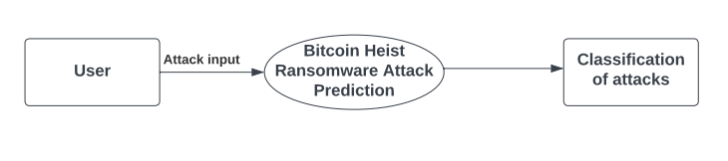

**Fig 4.1 Data Flow Diagram – Level 0**

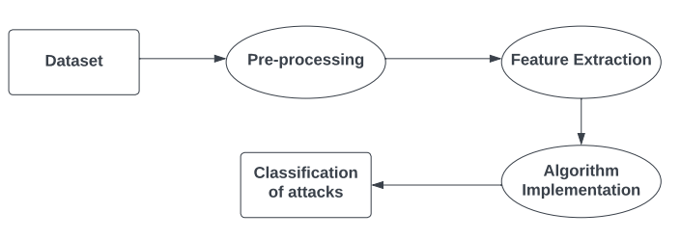 **Fig 4.2 Data Flow Diagram – Level 1**

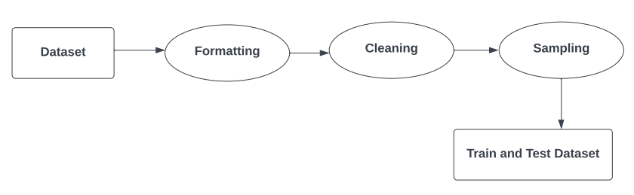

**Fig 4.3 Data Flow Diagram – Level 2**

**4.3 UML Diagrams**

A UML diagram is a diagram based on the UML (Unified Modeling Language) with the purpose of visually representing a system along with its main actors, roles, actions, artifacts or classes, in order to better understand, alter, maintain, or document information about the system.

**4.3.1 Use Case Diagram**

A use case diagram is used to represent the dynamic behavior of a system. It encapsulates the system's functionality by incorporating use cases, actors, and their relationships. It models the tasks, services, and functions required by a system/subsystem of an application. It depicts the high-level functionality of a system and also tells how the user handles a system.The main purpose of a use case diagram is to portray the dynamic aspect of a system. It accumulates the system's requirement, which includes both internal as well as external influences.It represents how an entity from the external environment can interact with a part of the system.

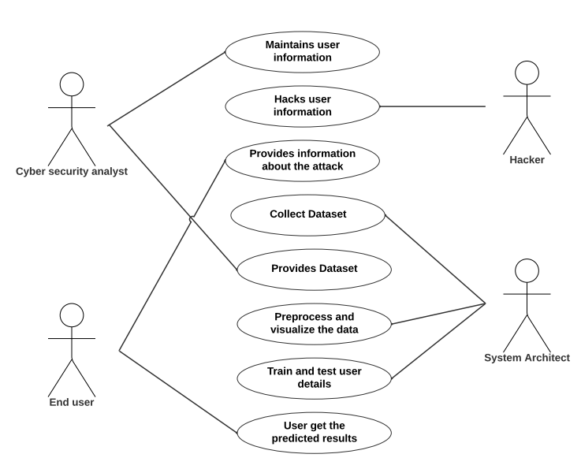

**Fig 4.4 Use Case Diagram**

**4.3.2 Sequence Diagram**

The sequence diagram represents the flow of messages in the system and is also termed as an event diagram. The sequence diagram is used primarily to show the interactions between objects in the sequential order that those interactions occur. It helps in envisioning several dynamic scenarios. It portrays the communication between any two lifelines as a time-ordered sequence of events, such that these lifelines took part at the run time. In UML, the lifeline is represented by a vertical bar, whereas the message flow is represented by a vertical dotted line that extends across the bottom of the page. It incorporates the iterations as well as branching.

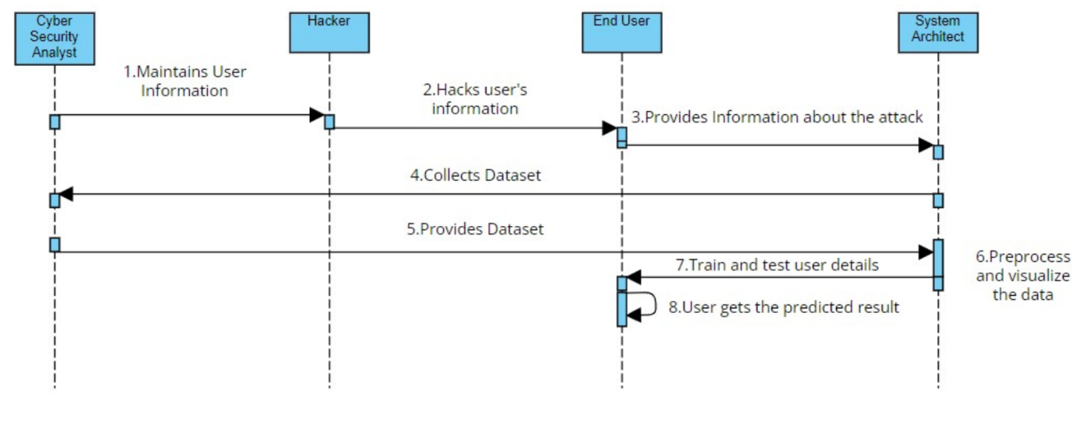

**Fig 4.5 Sequence Diagram**

**4.3.3 Activity Diagram**

Activity diagram is another important diagram in UML to describe the dynamic aspects of the system. Activity diagram is basically a flowchart to represent the flow from one activity to another activity. The activity can be described as an operation of the system. The control flow is drawn from one operation to another. This flow can be sequential, branched, or concurrent. Activity diagrams deal with all type of flow control by using different elements such as fork, join, etc.

Activity is a particular operation of the system. Activity diagrams are not only used for visualizing the dynamic nature of a system, but they are also used to construct the executable system by using forward and reverse engineering techniques. The only missing thing in the activity diagram is the message part.

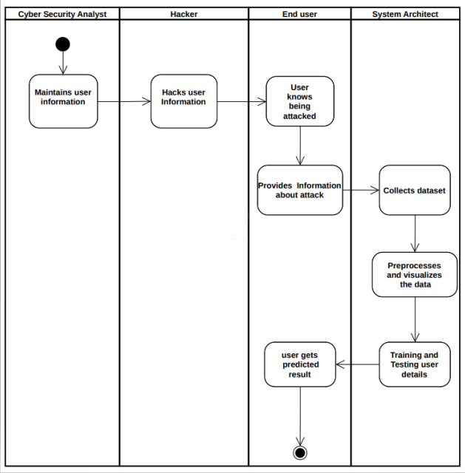



**Fig 4.6 Activity Diagram**

**CHAPTER 5**

**SYSTEM ARCHITECTURE**

**CHAPTER 5**

**SYSTEM ARCHITECTURE**

**5.1 System Architecture**

The Bitcoin Heist Ransomware Attack Prediction includes six different stages in order to predict the type of attacks. Generally, the first step will be collecting input from the user who wants to know what attack it is. Parallely, the network will have several collection of features stored in dataset for prediction. The data will be preprocessed by removing all the cleaning the raw data and make it as a valuable dataset. Then, the next stage will be data visualization which is done to have a better glance of vast amount of data. It can be either in graphs or in charts. Now the dataset provided by the user will be compared with the four machine learning algorithms such as Logistic Regression, Random Forest, XG Boost and Voting Classifier. After the comparison is done, the system will predict the best algorithm which gives efficient accuracy and builds the model. Then the deployment will be carried out.

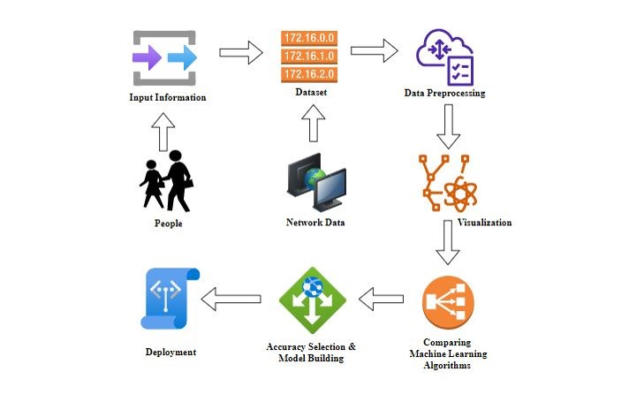

**Fig 5.1 System Architecture**

**CHAPTER 6**

**SYSTEM IMPLEMENTATION**

**CHAPTER 6**

**SYSTEM IMPLEMENTATION**

**6.1 Module Design Specification**

**6.1.1 Data Pre-processing**

Validation techniques in machine learning are used to get the error rate of the Machine Learning (ML) model, which can be considered as close to the true error rate of the dataset. If the data volume is large enough to be representative of the population, you may not need the validation techniques. However, in real-world scenarios, to work with samples of data that may not be a true representative of the population of given dataset. To finding the missing value, duplicate value and description of data type whether it is float variable or integer. The sample of data used to provide an unbiased evaluation of a model fit on the training dataset while tuning model hyper parameters.

The evaluation becomes more biased as skill on the validation dataset is incorporated into the model configuration. The validation set is used to evaluate a given model, but this is for frequent evaluation. It as machine learning engineers use this data to fine-tune the model hyper parameters. Data collection, data analysis, and the process of addressing data content, quality, and structure can add up to a time-consuming to-do list. During the process of data identification, it helps to understand your data and its properties; this knowledge will help you choose which algorithm to use to build your model.

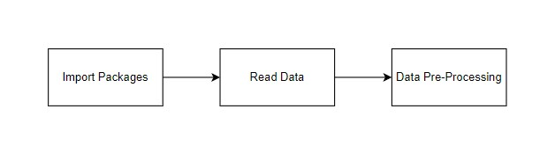

**Fig 6.1 Flow of Data Pre-processing**

A number of different **data cleaning** tasks using Python’s [Pandas library](https://pandas.pydata.org/) and specifically, it focus on probably the biggest data cleaning task, **missing values** and it able to **more**[**quickly clean data**](https://www.dataoptimal.com/data-cleaning-with-python-2018/). It wants to **spend less time cleaning data**, and more time exploring and modeling.

Some of these sources are just simple random mistakes. Other times, there can be a deeper reason why data is missing. It’s important to understand these [different types of missing data](https://en.wikipedia.org/wiki/Missing_data) from a statistics point of view. The type of missing data will influence how to deal with filling in the missing values and to detect missing values, and do some basic imputation and detailed statistical approach for [dealing with missing data](https://github.com/matthewbrems/ODSC-missing-data-may-18/blob/master/Analysis%20with%20Missing%20Data.pdf). Before, joint into code, it’s important to understand the sources of missing data. Here are some typical reasons why data is missing:

* User forgot to fill in a field.
* Data was lost while transferring manually from a legacy database.
* There was a programming error.
* Users chose not to fill out a field tied to their beliefs about how the results would be used or interpreted.

Variable identification with Uni-variate, Bi-variate and Multi-variate analysis:

* Import libraries for access and functional purpose and read the given dataset
* General Properties of Analyzing the given dataset
* Display the given dataset in the form of data frame
* Show columns
* Shape of the data frame
* To describe the data frame
* Checking data type and information about dataset
* Checking for duplicate data
* Checking Missing values of data frame
* Checking unique values of data frame
* Checking count values of data frame
* Rename and drop the given data frame
* To specify the type of values
* To create extra columns

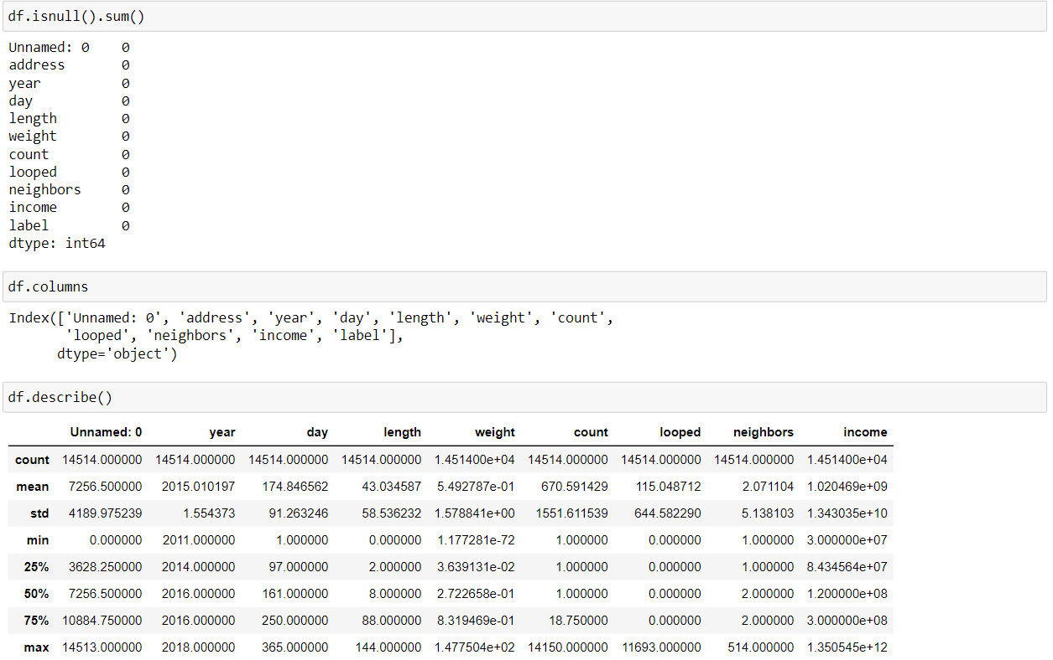

**Fig 6.2 Screenshot of Analysis of Data**

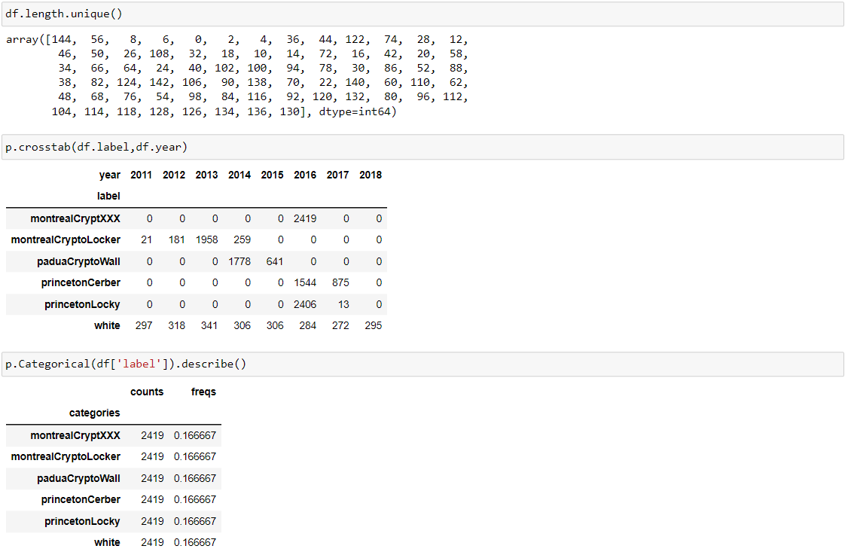

**Fig 6.3 Screenshot of Unique Data Categorization**

**6.1.2 Data Visualization**

Data visualization is an important skill in applied statistics and machine learning. Statistics does indeed focus on quantitative descriptions and estimations of data.

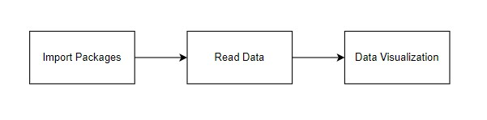

**Fig 6.4 Flow of Data Visualization**

Data visualization provides an important suite of tools for gaining a qualitative understanding. This can be helpful when exploring and getting to know a dataset and can help with identifying patterns, corrupt data, outliers, and much more. With a little domain knowledge, data visualizations can be used to express and demonstrate key relationships in plots and charts that are more visceral and stakeholders than measures of association or significance. Data visualization and exploratory data ole fields themselves and it will recommend a deeper dive into some the books mentioned at the end.

Sometimes data does not make sense until it can look at in a visual form, such as with charts and plots. Being able to quickly visualize of data samples and others is an important skill both in applied statistics analysis are when in applied machine learning. It will discover the many types of plots that you will need to know when visualizing data in Python and how to use them to better understand your own data.

* To chart time series data with line plots and categorical quantities with bar charts.
* To summarize data distributions with histograms and box plots.

The timeframe between 2011 and 2018 which resulted in 14514 transactions of labeled ransomware attacks are represented in the below graph of Fig 5.6.

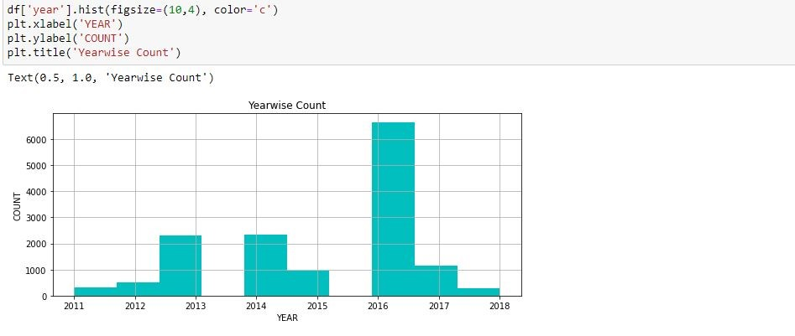

**Fig 6.5 Screenshot of Yearwise Count**

The categorised dataset should be a representative sample of the Bitcoin ecosystem, one could read that the ecosystem is composed by a relatively small portion of illicit activities-related entities. The transactional features with the path activities along the length to identify the label, thereby classifying a transaction into a specific ransomware family.

The result of visualising the categorised dataset which includes a total of 14514 entities represented into category of attack labels and percentage of attacks occurred in year are presented in the process of data visualization in Fig 5.7 and 5.8.

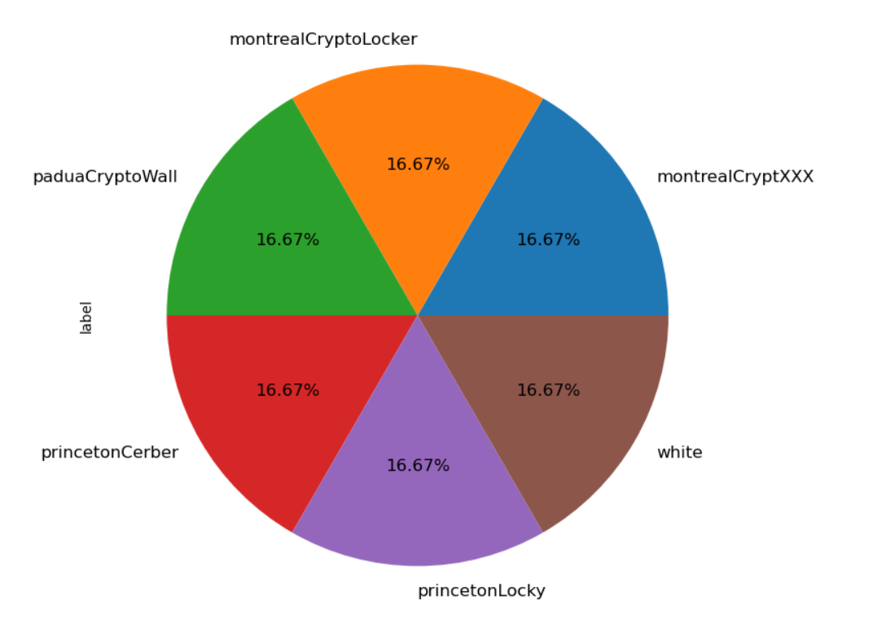

**Fig 6.6 Screenshot of piechart based on Label**

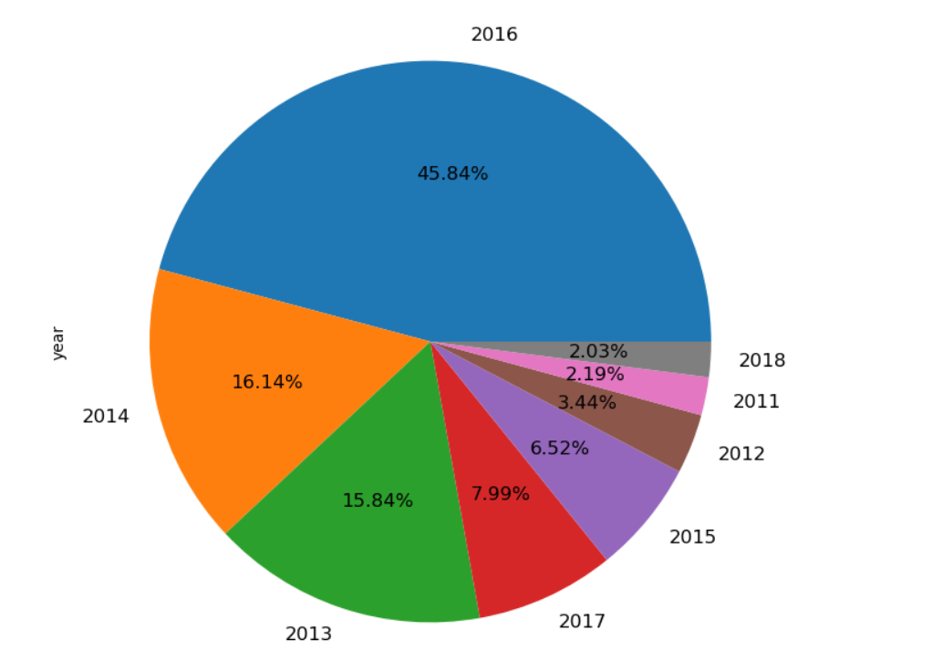

**Fig 6.7 Screenshot of piechart based on Year**

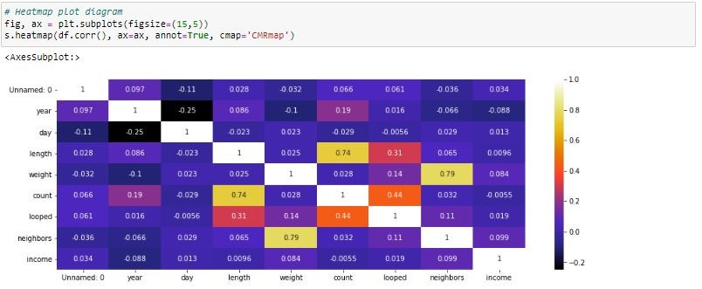

**Fig 6.8 Screenshot of Heatmap Plot Diagram**

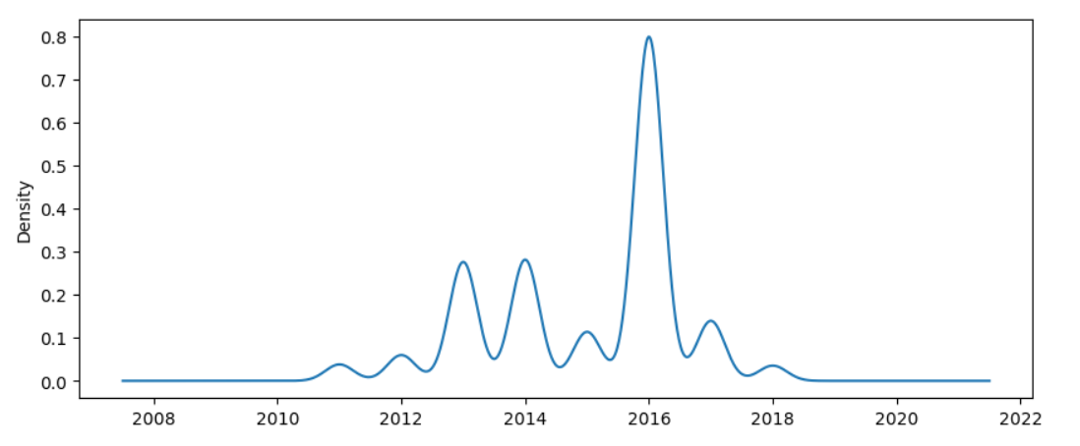

**Fig 6.9 Screenshot of Density Plot on Attacks**

**6.2 Algorithm Implementation**

It is important to compare the performance of multiple different machine learning algorithms consistently and it will discover to create a test harness to compare multiple different machine learning algorithms in Python with scikit-learn. It can use this test harness as a template on your own machine learning problems and add more and different algorithms to compare. Each model will have different performance characteristics. Using resampling methods like cross validation, you can get an estimate for how accurate each model may be on unseen data. It needs to be able to use these estimates to choose one or two best models from the suite of models that you have created. When have a new dataset, it is a good idea to visualize the data using different techniques in order to look at the data from different perspectives. The same idea applies to model selection. You should use a number of different ways of looking at the estimated accuracy of your machine learning algorithms in order to choose the one or two to finalize. A way to do this is to use different visualization methods to show the average accuracy, variance and other properties of the distribution of model accuracies.

In the next section you will discover exactly how you can do that in Python with scikit-learn. The key to a fair comparison of machine learning algorithms is ensuring that each algorithm is evaluated in the same way on the same data and it can achieve this by forcing each algorithm to be evaluated on a consistent test harness. The below 4 different algorithms are compared:

1. Logistic Regression
2. Random Forest Classifier
3. XG Boost Classifier
4. Voting Classifier

**6.2.1 Logistic Regression**

Logistic regression is another powerful supervised ML algorithm used for binary classification problems (when target is categorical). The best way to think about logistic regression is that it is a linear regression but for classification problems. Logistic regression essentially uses a logistic function defined below to model a binary output variable (Tolles & Meurer, 2016). The primary difference between linear regression and logistic regression is that logistic regression's range is bounded between 0 and 1.

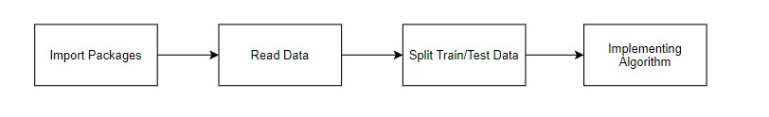

**Fig 6.10 Flow of Logistic Regression**

In addition, as opposed to linear regression, logistic regression does not require a linear relationship between inputs and output variables.

**6.2.2 Random Forest Classifier**

Random Forest is a popular machine learning algorithm that belongs to the supervised learning technique. It can be used for both Classification and Regression problems in ML. It is based on the concept of ensemble learning, which is a process of combining multiple classifiers to solve a complex problem and to improve the performance of the model.



**Fig 6.11 Flow of Random Forest Classifier**

As the name suggests, "Random Forest is a classifier that contains a number of decision trees on various subsets of the given dataset and takes the average to improve the predictive accuracy of that dataset." Instead of relying on one decision tree, the random forest takes the prediction from each tree and based on the majority votes of predictions, and it predicts the final output. The greater number of trees in the forest leads to higher accuracy and prevents the problem of overfitting.

**6.2.3 XG Boost Classifier**

The speed and performance are unparalleled and it consistently outperforms any other algorithms aimed at supervised learning tasks. The library is parallelizable which means the core algorithm can run on clusters of GPUs or even across a network of computers.



**Fig 6.12 Flow of XG Boost Classifier**

This makes it feasible to solve ML tasks by training on hundreds of millions of training examples with high performance.

**6.2.4 Voting Classifier**

A Voting Classifier is a machine learning model that trains on an ensemble of numerous models and predicts an output (class) based on their highest probability of chosen class as the output. It simply aggregates the findings of each classifier passed into Voting Classifier and predicts the output class based on the highest majority of voting.

The idea is instead of creating separate dedicated models and finding the accuracy for each them, we create a single model which trains by these models and predicts output based on their combined majority of voting for each output class.

**CHAPTER 7**

**PERFORMANCE ANALYSIS**

**CHAPTER 7**

**PERFORMANCE ANALYSIS**

**7.1 Performance Metrics**

**Accuracy:** The Proportion of the total number of predictions that is correct otherwise overall how often the model predicts correctly defaulters and non-defaulters.

Accuracy calculation:

Accuracy = (TP + TN) / (TP + TN + FP + FN)

Accuracy is the most intuitive performance measure and it is simply a ratio of correctly predicted observation to the total observations. One may think that, if we have high accuracy then our model is best. Yes, accuracy is a great measure but only when you have symmetric datasets where values of false positive and false negatives are almost same.

**Precision:** The proportion of positive predictions that are actually correct.

Precision = TP / (TP + FP)

Precision is the ratio of correctly predicted positive observations to the total predicted positive observations. The question that this metric answer is of all passengers that labelled as survived, how many actually survived? High precision relates to the low false positive rate. We have got 0.788 precision which is pretty good.

**Recall:** The proportion of positive observed values correctly predicted. (The proportion of actual defaulters that the model will correctly predict)

Recall = TP / (TP + FN)

Recall (Sensitivity) - Recall is the ratio of correctly predicted positive observations to the all observations in actual class - yes.

**F1-score:** F1 Score is the weighted average of Precision and Recall. Therefore, this score takes both false positives and false negatives into account. Intuitively it is not as easy to understand as accuracy, but F1 is usually more useful than accuracy, especially if you have an uneven class distribution. Accuracy works best if false positives and false negatives have similar cost. If the cost of false positives and false negatives are very different, it’s better to look at both Precision and Recall.

F- Measure = 2TP / (2TP + FP + FN)

F1-Score Formula:

F1 Score = 2*(Recall * Precision) / (Recall + Precision)

**False Positives (FP):** A person who will pay predicted as defaulter. When actual class is no and predicted class is yes. (e.g)., if actual class says this passenger did not survive but predicted class tells you that this passenger will survive.

**False Negatives (FN):** A person who default predicted as payer. When actual class is yes but predicted class in no. (e.g)., if actual class value indicates that this passenger survived and predicted class tells you that passenger will die.

**True Positives (TP):** A person who will not pay predicted as defaulter. These are the correctly predicted positive values which means that the value of actual class is yes and the value of predicted class is also yes. (e.g)., if actual class value indicates that this passenger survived and predicted class tells you the same thing.

**True Negatives (TN):** A person who default predicted as payer. These are the correctly predicted negative values which means that the value of actual class is no and value of predicted class is also no. (e.g)., if actual class says this passenger did not survive and predicted class tells you the same thing.

True Positive rate (TPR) = TP / (TP + FN)

False Positive rate (FPR) = FP / (FP + TN)

**7.2 Classification Report of Algorithms**

The entire dataset includes 14514 features with 10159 of training data and 4355 of testing data and ran different features selection tests and assessed that length, and weight of a transaction in combination with income are the best predictors of the class label which gave the following predicted results.

|  |  |  |  |  |
| --- | --- | --- | --- | --- |
|  | **Precision** | **Recall** | **F1-score** | **Support** |
| **0** | 0.00 | 0.00 | 0.00 | 726 |
| **1** | 0.00 | 0.00 | 0.00 | 726 |
| **2** | 0.00 | 0.00 | 0.00 | 725 |
| **3** | 0.00 | 0.00 | 0.00 | 726 |
| **4** | 0.00 | 0.00 | 0.00 | 726 |
| **5** | 0.17 | 1.00 | 0.29 | 726 |
| **Accuracy** |  |  | 0.17 | 4355 |
| **Macro average** | 0.03 | 0.17 | 0.05 | 4355 |
| **Weighted average** | 0.03 | 0.17 | 0.05 | 4355 |

**Table 7.1 Classification Report of Logistic Regression**

|  |  |  |  |  |
| --- | --- | --- | --- | --- |
|  | **Precision** | **Recall** | **F1-score** | **Support** |
| **0** | 0.89 | 0.95 | 0.92 | 726 |
| **1** | 0.96 | 0.96 | 0.96 | 726 |
| **2** | 0.87 | 0.91 | 0.89 | 725 |
| **3** | 0.89 | 0.97 | 0.93 | 726 |
| **4** | 0.96 | 0.97 | 0.96 | 726 |
| **5** | 0.86 | 0.67 | 0.75 | 726 |
| **Accuracy** |  |  | 0.90 | 4355 |
| **Macro average** | 0.90 | 0.91 | 0.90 | 4355 |
| **Weighted average** | 0.90 | 0.91 | 0.90 | 4355 |

**Table 7.2 Classification Report of Random Forest Classifier**

|  |  |  |  |  |
| --- | --- | --- | --- | --- |
|  | **Precision** | **Recall** | **F1-score** | **Support** |
| **0** | 0.90 | 0.95 | 0.93 | 726 |
| **1** | 0.97 | 0.97 | 0.97 | 726 |
| **2** | 0.86 | 0.92 | 0.89 | 725 |
| **3** | 0.91 | 0.98 | 0.94 | 726 |
| **4** | 0.97 | 0.97 | 0.97 | 726 |
| **5** | 0.85 | 0.69 | 0.76 | 726 |
| **Accuracy** |  |  | 0.91 | 4355 |
| **Macro average** | 0.91 | 0.91 | 0.91 | 4355 |
| **Weighted average** | 0.91 | 0.91 | 0.91 | 4355 |

**Table 7.3 Classification Report of XG Boost Classifier**

|  |  |  |  |  |
| --- | --- | --- | --- | --- |
|  | **Precision** | **Recall** | **F1-score** | **Support** |
| **0** | 0.89 | 0.95 | 0.92 | 726 |
| **1** | 0.97 | 0.96 | 0.97 | 726 |
| **2** | 0.88 | 0.90 | 0.89 | 725 |
| **3** | 0.92 | 0.96 | 0.94 | 726 |
| **4** | 0.98 | 0.96 | 0.97 | 726 |
| **5** | 0.83 | 0.74 | 0.78 | 726 |
| **Accuracy** |  |  | 0.91 | 4355 |
| **Macro average** | 0.91 | 0.91 | 0.91 | 4355 |
| **Weighted average** | 0.91 | 0.91 | 0.91 | 4355 |

**Table 7.4 Classification Report of Voting Classifier**

**7.3 Confusion Matrix Plot**

The confusion matrix is implemented for the algorithms evaluated and plotted in the form of graphs for the performance metrics calculated. The algorithms are specified as: Ce-Cerber, Cr-Crypto, Cr.L-Crypto Locker, Cr.W-Crypto Wall, Lo-Locker, W-White.

|  |  |  |  |  |  |  |
| --- | --- | --- | --- | --- | --- | --- |
|  | Ce | Cr | Cr.L | Cr.W | Lo | W |
| Ce | 0 | 0 | 0 | 0 | 0 | 726 |
| Cr | 0 | 0 | 0 | 0 | 0 | 726 |
| Cr.L | 0 | 0 | 0 | 0 | 0 | 725 |
| Cr.W | 0 | 0 | 0 | 0 | 0 | 726 |
| Lo | 0 | 0 | 0 | 0 | 0 | 726 |
| W | 0 | 0 | 0 | 0 | 0 | 726 |

**Table 7.5 Confusion Matrix of Logistic Regression**

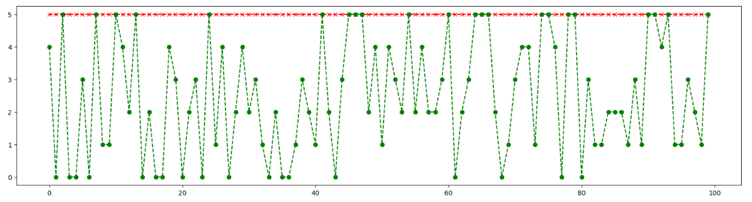

|  |  |  |  |  |  |  |
| --- | --- | --- | --- | --- | --- | --- |
|  | Ce | Cr | Cr.L | Cr.W | Lo | W |
| Ce | 691 | 15 | 0 | 0 | 9 | 11 |
| Cr | 22 | 696 | 0 | 0 | 6 | 2 |
| Cr.L | 0 | 0 | 663 | 15 | 0 | 47 |
| Cr.W | 0 | 0 | 1 | 705 | 0 | 20 |
| Lo | 18 | 3 | 0 | 0 | 703 | 2 |
| W | 45 | 8 | 97 | 73 | 18 | 485 |

**Fig 7.1 Screenshot of Plot of Logistic Regression**

**Table 7.6 Confusion Matrix of Random Forest Classifier**

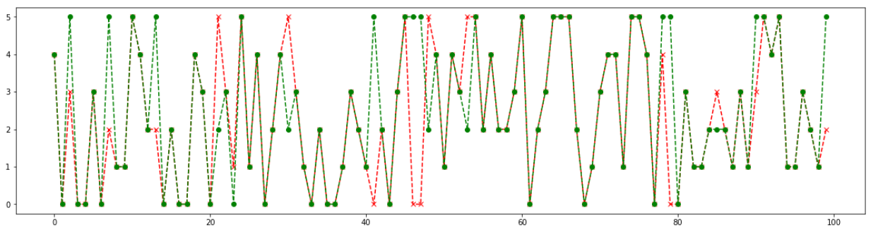

**Fig 7.2 Screenshot of Plot of Random Forest Classifier**

|  |  |  |  |  |  |  |
| --- | --- | --- | --- | --- | --- | --- |
|  | Ce | Cr | Cr.L | Cr.W | Lo | W |
| Ce | 690 | 12 | 0 | 0 | 8 | 16 |
| Cr | 17 | 707 | 0 | 0 | 0 | 2 |
| Cr.L | 0 | 0 | 664 | 12 | 0 | 49 |
| Cr.W | 0 | 0 | 0 | 710 | 0 | 16 |
| Lo | 14 | 0 | 0 | 0 | 706 | 6 |
| W | 43 | 8 | 107 | 56 | 11 | 501 |

**Table 7.7 Confusion Matrix of XG Boost Classifier**

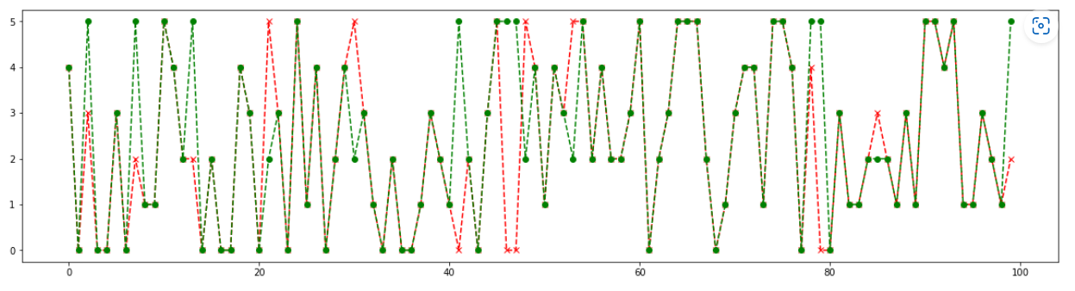

**Fig 7.3 Screenshot of Plot of XG Boost Classifier**

|  |  |  |  |  |  |  |
| --- | --- | --- | --- | --- | --- | --- |
|  | Ce | Cr | Cr.L | Cr.W | Lo | W |
| Ce | 692 | 11 | 0 | 0 | 3 | 20 |
| Cr | 26 | 697 | 0 | 0 | 0 | 3 |
| Cr.L | 0 | 0 | 655 | 12 | 0 | 58 |
| Cr.W | 0 | 0 | 1 | 699 | 0 | 26 |
| Lo | 19 | 3 | 0 | 0 | 698 | 6 |
| W | 39 | 7 | 88 | 47 | 9 | 536 |

**Table 7.8 Confusion Matrix of Voting Classifier**

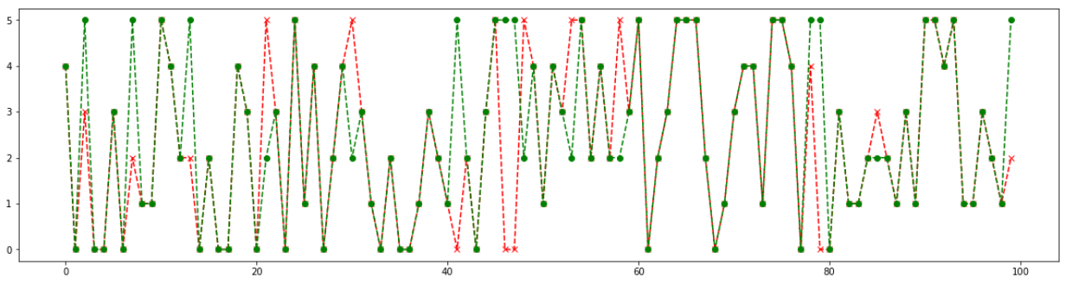

**Fig 7.4 Screenshot of Plot of Voting Classifier**

**7.4 Results and Discussion**

Bitcoin, a peer-to-peer electronic payment system and digital currency that relies on blockchain technology, has caught the attention of researchers as well as the mainstream media. With the rise of cybercrime activities appearing on headlines, altogether with Bitcoins being involved in scamming, ransomware attacks, tor-markets, and thievery, the cryptocurrency has been commonly associated with only nefarious activities.

The objective of the work is to help towards building a better understanding of the ransomware threat landscape. It introduces a practical approach for building effective tools for detection and mitigation of ransomware attacks by monitoring their pre-attack activities and attributing them to known families during early phases. The goal is to develop a machine learning model for Crypto Ransomware Attack Prediction. To potentially replace the updatable supervised machine learning classification models by predicting results in the form of best accuracy by comparing supervised algorithm.

The machine learning model is designed to work on the bitcoin heist data set to classify the different malicious transactions. The different transactions features are analyzed to predict a classifier label among the classifiers that have been identified as ransomware or associated with malicious activity. The main scope is to detect the Crypto Ransomware attack Prediction, which is a classic text classification problem with a help of machine learning algorithm. It is needed to build a model that can differentiate Crypto Ransomware attacks. The results are assessed to evaluate accuracy, precision, and recall for the algorithms implemented on each module. After the analysis, it has been identified that XG Boost Classifier algorithm performed with better accuracy of 91.34%.

**CHAPTER 8**

**CONCLUSION**

**CHAPTER 8**

**CONCLUSION**

**8.1 Conclusion and Future Enhancements**

In this work, we proposed an analysis for attributing ransomware samples based on their behavioral characteristics/features following their activities. The analytical process started from data cleaning and processing, missing value, exploratory analysis and finally model building and evaluation. The best accuracy on public test set is higher accuracy score will be find out. This application can help to find the Prediction of Crypto Ransomware attack. This way can help the organisations to know more about the attacks and also will be able to identify the attacks from spam, phishing emails, malicious and hacked websites.

The future works can be implemented on Crypto Ransomware attack prediction which can be connected with the cloud model. The optimization of this work can also be better if the system and the prediction model is connected with the embedded system. Finally, with further development of the model and a reﬁned methodology, it can be used to produce estimations of the entire ecosystem and reveal past, current and future cybercrime trends.

**APPENDICES**

**A.1 Sample Dataset**

|  |  |  |  |  |  |  |  |  |
| --- | --- | --- | --- | --- | --- | --- | --- | --- |
| **Year** | **Day** | **Length** | **Weight** | **Count** | **Looped** | **Neighbors** | **Income** | **Label** |
| 2016 | 146 | 144 | 0.877485 | 4817 | 0 | 1 | 1.04E+08 | montrealCryptXXX |
| 2016 | 158 | 56 | 3.05E-05 | 1 | 0 | 1 | 1.2E+08 | montrealCryptXXX |
| 2016 | 156 | 8 | 0.75 | 2 | 0 | 4 | 2.4E+08 | montrealCryptXXX |
| 2016 | 155 | 6 | 0.5 | 6 | 0 | 2 | 1.2E+08 | montrealCryptXXX |
| 2016 | 137 | 0 | 1 | 1 | 0 | 2 | 1.2E+08 | montrealCryptXXX |
| 2016 | 182 | 2 | 0.5 | 1 | 0 | 1 | 1.22E+08 | montrealCryptXXX |
| 2016 | 168 | 144 | 0.407676 | 3060 | 0 | 2 | 1.2E+08 | montrealCryptXXX |
| 2016 | 163 | 4 | 0.333333 | 1 | 0 | 2 | 1.2E+08 | montrealCryptXXX |
| 2016 | 160 | 144 | 0.148449 | 4309 | 0 | 2 | 1.2E+08 | montrealCryptXXX |
| 2016 | 161 | 0 | 0.2 | 1 | 0 | 2 | 1.2E+08 | montrealCryptXXX |
| 2016 | 158 | 0 | 1 | 1 | 0 | 2 | 1.2E+08 | montrealCryptXXX |
| 2013 | 43 | 0 | 1 | 1 | 0 | 2 | 7E+09 | montrealCryptoLocker |
| 2012 | 232 | 0 | 0.5 | 1 | 0 | 1 | 7.17E+09 | montrealCryptoLocker |
| 2013 | 311 | 18 | 0.261719 | 5 | 0 | 4 | 3.82E+08 | montrealCryptoLocker |
| 2013 | 289 | 22 | 0.535714 | 2 | 2 | 4 | 3.95E+08 | montrealCryptoLocker |
| 2013 | 191 | 2 | 1 | 1 | 1 | 4 | 4E+08 | montrealCryptoLocker |
| 2013 | 112 | 0 | 0.5 | 1 | 0 | 2 | 2.83E+08 | montrealCryptoLocker |
| 2013 | 296 | 0 | 0.018868 | 1 | 0 | 2 | 1E+08 | montrealCryptoLocker |
| 2013 | 187 | 0 | 1 | 1 | 0 | 1 | 6.72E+09 | montrealCryptoLocker |
| 2014 | 136 | 80 | 1.015734 | 6 | 0 | 3 | 1.06E+08 | montrealCryptoLocker |
| 2013 | 342 | 4 | 1.03125 | 3 | 0 | 2 | 1.23E+08 | montrealCryptoLocker |
| 2014 | 161 | 144 | 9.929136 | 785 | 13 | 27 | 2.71E+09 | paduaCryptoWall |
| 2014 | 132 | 6 | 0.5 | 1 | 0 | 1 | 50000000 | paduaCryptoWall |
| 2014 | 112 | 14 | 0.605469 | 22 | 22 | 2 | 8.97E+08 | paduaCryptoWall |
| 2014 | 101 | 0 | 0.5 | 1 | 0 | 1 | 4.85E+08 | paduaCryptoWall |
| 2014 | 184 | 0 | 1 | 1 | 0 | 1 | 1.57E+08 | paduaCryptoWall |
| 2015 | 320 | 144 | 0.851403 | 3814 | 0 | 1 | 1.64E+08 | paduaCryptoWall |
| 2014 | 103 | 6 | 0.111111 | 5 | 0 | 1 | 1.06E+08 | paduaCryptoWall |
| 2014 | 167 | 64 | 5.000024 | 23 | 17 | 12 | 1.63E+09 | paduaCryptoWall |
| 2014 | 90 | 144 | 0.454227 | 1665 | 0 | 2 | 5E+08 | paduaCryptoWall |
| 2014 | 105 | 0 | 1 | 1 | 0 | 1 | 35000000 | paduaCryptoWall |
| 2017 | 74 | 6 | 0.001736 | 1 | 0 | 2 | 80000000 | princetonCerber |
| 2017 | 109 | 10 | 0.001563 | 1 | 0 | 2 | 80000000 | princetonCerber |
| 2017 | 124 | 144 | 0.00095 | 5646 | 0 | 2 | 60000000 | princetonCerber |
| 2017 | 26 | 0 | 1 | 1 | 0 | 2 | 67750000 | princetonCerber |
| 2016 | 116 | 144 | 0.020677 | 2986 | 0 | 2 | 1.25E+08 | princetonCerber |
| 2016 | 294 | 64 | 1.000061 | 2 | 0 | 4 | 2E+08 | princetonCerber |
| 2016 | 152 | 2 | 1.5 | 2 | 0 | 2 | 2.65E+08 | princetonCerber |
| 2017 | 141 | 38 | 0.000244 | 1 | 0 | 2 | 50000000 | princetonCerber |
| 2016 | 309 | 42 | 7.63E-06 | 1 | 0 | 2 | 1E+08 | princetonCerber |
| 2016 | 363 | 34 | 0.000488 | 1 | 0 | 2 | 70000000 | princetonCerber |
| 2016 | 153 | 2 | 0.5 | 1 | 0 | 2 | 4E+08 | princetonLocky |
| 2016 | 275 | 0 | 0.333333 | 1 | 0 | 1 | 3E+08 | princetonLocky |
| 2016 | 57 | 6 | 1 | 1 | 0 | 1 | 50000000 | princetonLocky |
| 2016 | 95 | 144 | 0.010929 | 2017 | 0 | 1 | 4.1E+08 | princetonLocky |
| 2016 | 202 | 144 | 0.250109 | 4538 | 0 | 1 | 2.5E+08 | princetonLocky |
| 2016 | 54 | 0 | 1 | 1 | 0 | 1 | 1E+08 | princetonLocky |
| 2016 | 47 | 144 | 0.250045 | 5336 | 0 | 1 | 50000000 | princetonLocky |
| 2016 | 267 | 24 | 0.007813 | 1 | 0 | 1 | 4E+08 | princetonLocky |
| 2016 | 186 | 2 | 0.25 | 2 | 0 | 1 | 4E+08 | princetonLocky |
| 2016 | 58 | 4 | 1 | 1 | 0 | 1 | 1E+08 | princetonLocky |
| 2018 | 42 | 2 | 1 | 1 | 0 | 2 | 1.87E+08 | white |
| 2018 | 247 | 144 | 0.071327 | 5564 | 2704 | 2 | 6.51E+08 | white |
| 2012 | 55 | 0 | 0.5 | 1 | 0 | 2 | 4.77E+09 | white |
| 2018 | 27 | 144 | 0.006431 | 4345 | 0 | 2 | 1E+08 | white |
| 2014 | 276 | 28 | 0.0625 | 1 | 0 | 2 | 65000000 | white |
| 2018 | 78 | 48 | 1 | 1 | 0 | 2 | 1.95E+08 | white |
| 2018 | 215 | 120 | 0.116467 | 5175 | 0 | 2 | 47578655 | white |
| 2018 | 234 | 12 | 1 | 1 | 0 | 2 | 7.85E+08 | white |
| 2014 | 153 | 0 | 1 | 1 | 0 | 2 | 30000000 | white |

**Table A.1 Sample Dataset**

**A.2 Sample Coding**

**A.2.1 Server side coding**

**Module** - **1: Data Pre**-**processing**

import pandas as p

import numpy as n

import warnings

warnings**.**filterwarnings('ignore')

data**.**head()

data**.**shape

df **=** data**.**dropna()

df**.**shape

df**.**isnull()**.**sum()

df**.**columns

df**.**describe()

df**.**length**.**unique()

p**.**crosstab(df**.**label,df**.**year)

p**.**Categorical(df['label'])**.**describe()

p**.**Categorical(df['year'])**.**describe()

print("Days: ", sorted(df['day']**.**unique()))

df['length']**.**value_counts()

df**.**duplicated()

df**.**duplicated()**.**sum()

df**.**columns

print("Minimum Income : ", df**.**income**.**min())

print("Maximum Income : ", df**.**income**.**max())

df**.**info()

df['label']

var_mod **=** ['label']

le **=** LabelEncoder()

for i in var_mod:

df[i] **=** le**.**fit_transform(df[i])**.**astype(int)

df['label']

# **Module** - **2: Data Visualization**

import pandas as p

import matplotlib.pyplot as plt

import seaborn as s

import numpy as n

warnings**.**filterwarnings('ignore')

df **=** p**.**read_csv("Data.csv")

df

df**.**columns

df['year']**.**hist(figsize**=**(10,4), color**=**'c')

plt**.**xlabel('YEAR')

plt**.**ylabel('COUNT')

plt**.**title('Yearwise Count')

def PropByVar(df, variable):

dataframe_pie **=** df[variable]**.**value_counts()

ax **=** dataframe_pie**.**plot**.**pie(figsize**=**(8,8), autopct**=**'%1.2f%%', fontsize **=** 12)

ax**.**set_title(variable **+** ' \n', fontsize **=** 15)

return n**.**round(dataframe_pie**/**df**.**shape[0]**\***100,2)

PropByVar(df, 'label')

def PropByVar(df, variable):

dataframe_pie **=** df[variable]**.**value_counts()

ax **=** dataframe_pie**.**plot**.**pie(figsize**=**(8,8), autopct**=**'%1.2f%%', fontsize **=** 12)

ax**.**set_title(variable **+** ' \n', fontsize **=** 15)

return n**.**round(dataframe_pie**/**df**.**shape[0]**\***100,2)

PropByVar(df, 'year')

fig, ax **=** plt**.**subplots(figsize**=**(15,5))

s**.**heatmap(df**.**corr(), ax**=**ax, annot**=**True, cmap**=**'CMRmap')

plt**.**figure(figsize**=**(12,5))

plt**.**scatter(df["year"],df["label"],color**=**"m")

plt**.**title('Scatter Plot')

plt**.**show()

plt**.**plot(df["year"], df["label"], color**=**'red')

plt**.**xlabel('year')

plt**.**ylabel('Attack Types')

plt**.**title('Distribution of Year and Attack_Types')

plt**.**show()

import seaborn as s

s**.**boxplot(df['day'], color**=**'y')

plt**.**figure(figsize**=** (10,4))

df["year"]**.**plot(kind**=**'density')

# **Module** - **3: XG Boost Classifier**

import pandas as p

import warnings

warnings**.**filterwarnings('ignore')

data **=** p**.**read_csv("Data.csv")

df = data.dropna()

df

del df['Unnamed: 0']

del df['address']df['label']=df['label'].map({'montrealCryptXXX':'Crypto','montrealCryptoLocker':'CryptoLocker','paduaCryptoWall':'CryptoWall','princetonCerber':'Cerber','princetonLocky':'Locky','white':'White'})

df.info()

df['label'].unique()

from sklearn.preprocessing import LabelEncoder

col = ['label']

label = LabelEncoder()

for i in col:

df[i] **=** label**.**fit_transform(df[i])**.**astype(int)

df['label']**.**unique()

df

X **=** df**.**drop(labels**=**'label', axis**=**1)

y **=** df**.**loc[:,'label']

from sklearn.model_selection import train_test_split

X_train, X_test, y_train, y_test = train_test_split(X, y, test_size=0.3, random_state=1, stratify=y)

print("Number of Training Dataset: ", len(X_train))

print("Number of Testing Dataset: ", len(X_test))

print("Total Number of Dataset: ", len(X_train)**+**len(X_test))

XGBoost Classifier:

from xgboost import XGBClassifier

from sklearn.metrics import confusion_matrix, classification_report, accuracy_score, plot_confusion_matrix

Training Process:

xg = XGBClassifier()

xg.fit(X_train,y_train)

predicted_xg = xg.predict(X_test)

Getting Accuracy:

accuracy = accuracy_score(y_test,predicted_xg)

print('Accuracy of XGBoost Classifier is: ',accuracy*100)

Finding Classification Report:

cr = classification_report(y_test,predicted_xg)

print('Classification report\n---------------------\n',cr)

Finding Confusion Matrix:

cm = confusion_matrix(y_test,predicted_xg)

print('Confusion matrix\n----------------\n',cm)

import matplotlib.pyplot as plt

fig, ax = plt.subplots(figsize=(7,7))

plot_confusion_matrix(xg, X_test, y_test, ax=ax)

plt.title('Confusion Matrix of XGBoost Classifier\n')

plt**.**show()

DF **=** p**.**DataFrame()

DF["y_test"] **=** y_test

DF["predicted"] **=** predicted_xg

DF**.**reset_index(inplace**=**True)

plt**.**figure(figsize**=**(20, 5))

plt**.**plot(DF["predicted"][:100], marker**=**'x', linestyle**=**'dashed', color**=**'red')

plt**.**plot(DF["y_test"][:100], marker**=**'o', linestyle**=**'dashed', color**=**'green')

plt**.**show()

Saving Model:

import joblib

joblib.dump(xg,'xgb.pkl')

# **Module** - **4: Random Forest Classifier**

import pandas as p

import warnings

warnings.filterwarnings('ignore')

data = p.read_csv("Data.csv")

df = data.dropna()

df

del df['Unnamed: 0']

del df['address']

df['label']=df['label'].map({'montrealCryptXXX':'Crypto','montrealCryptoLocker':'CryptoLocker','paduaCryptoWall':'CryptoWall','princetonCerber':'Cerber','princetonLocky':'Locky','white':'White'})

df.info()

df['label'].unique()

from sklearn.preprocessing import LabelEncoder

col = ['label']

label = LabelEncoder()

for i in col:

df[i] = label.fit_transform(df[i]).astype(int)

df['label'].unique()

df

X **=** df**.**drop(labels**=**'label', axis**=**1)

y **=** df**.**loc[:,'label']

from sklearn.model_selection import train_test_split

X_train, X_test, y_train, y_test = train_test_split(X, y, test_size=0.3, random_state=1, stratify=y)

print("Number of Training Dataset: ", len(X_train))

print("Number of Testing Dataset: ", len(X_test))

print("Total Number of Dataset: ", len(X_train)+len(X_test))

Random Forest Classifier:

from sklearn.ensemble import RandomForestClassifier

from sklearn.metrics import confusion_matrix, classification_report, accuracy_score, plot_confusion_matrix

Training Process:

rfc = RandomForestClassifier()

rfc.fit(X_train,y_train)

predicted_rfc = rfc.predict(X_test)

Getting Accuracy:

accuracy = accuracy_score(y_test,predicted_rfc)

print('Accuracy of Random Forest Classifier is: ',accuracy*100)

Finding Classification Report:

cr = classification_report(y_test,predicted_rfc)

print('Classification report\n---------------------\n',cr)

Finding Confusion Matrix:

cm **=** confusion_matrix(y_test,predicted_rfc)

print('Confusion matrix\n----------------\n',cm)

import matplotlib.pyplot as plt

fig, ax = plt.subplots(figsize=(7,7))

plot_confusion_matrix(rfc, X_test, y_test, ax=ax)

plt.title('Confusion Matrix of Random Forest Classifier\n')

plt.show()

DF **=** p**.**DataFrame()

DF["y_test"] **=** y_test

DF["predicted"] **=** predicted_rfc

DF**.**reset_index(inplace**=**True)

plt**.**figure(figsize**=**(20, 5))

plt**.**plot(DF["predicted"][:100], marker**=**'x', linestyle**=**'dashed', color**=**'red')

plt**.**plot(DF["y_test"][:100], marker**=**'o', linestyle**=**'dashed', color**=**'green')

plt**.**show()

**Module** - **5: Logistic Regression**

import pandas as p

import warnings

warnings.filterwarnings('ignore')

data = p.read_csv("Data.csv")

df **=** data**.**dropna()

df

del df['Unnamed: 0']

del df['address']

df['label']=df['label'].map({'montrealCryptXXX':'Crypto','montrealCryptoLocker':'CryptoLocker','paduaCryptoWall':'CryptoWall','princetonCerber':'Cerber','princetonLocky':'Locky','white':'White'})

df.info()

df['label'].unique()

from sklearn.preprocessing import LabelEncoder

col = ['label']

label = LabelEncoder()

for i in col:

df[i] = label.fit_transform(df[i]).astype(int)

df['label'].unique()

df

X = df.drop(labels='label', axis=1)

y = df.loc[:,'label']

from sklearn.model_selection import train_test_split

X_train, X_test, y_train, y_test = train_test_split(X, y, test_size=0.3, random_state=1, stratify=y)

print("Number of Training Dataset: ", len(X_train))

print("Number of Testing Dataset: ", len(X_test))

print("Total Number of Dataset: ", len(X_train)**+**len(X_test))

Logistic Regression:

from sklearn.linear_model import LogisticRegression

from sklearn.metrics import confusion_matrix, classification_report, accuracy_score, plot_confusion_matrix

Training Process:

lr = LogisticRegression()

lr.fit(X_train,y_train)

predicted_lr = lr.predict(X_test)

Getting Accuracy:

accuracy = accuracy_score(y_test,predicted_lr)

print('Accuracy of Logistic Regression is: ',accuracy*100)

Finding Classification Report:

cr = classification_report(y_test,predicted_lr)

print('Classification report\n---------------------\n',cr)

Finding Confusion Matrix:

cm **=** confusion_matrix(y_test,predicted_lr)

print('Confusion matrix\n----------------\n',cm)

import matplotlib.pyplot as plt

fig, ax = plt.subplots(figsize=(7,7))

plot_confusion_matrix(lr, X_test, y_test, ax=ax)

plt.title('Confusion Matrix of Logistic Regression\n')

plt.show()

DF = p.DataFrame()

DF["y_test"] = y_test

DF["predicted"] = predicted_lr

DF**.**reset_index(inplace**=**True)

plt**.**figure(figsize**=**(20, 5))

plt**.**plot(DF["predicted"][:100], marker**=**'x', linestyle**=**'dashed', color**=**'red')

plt**.**plot(DF["y_test"][:100], marker**=**'o', linestyle**=**'dashed', color**=**'green')

plt**.**show()

**Module** - **6: Voting Classifier**

import pandas as p

import warnings

warnings.filterwarnings('ignore')

data = p.read_csv("Data.csv")

df **=** data**.**dropna()

df

del df['Unnamed: 0']

del df['address']

df['label']=df['label'].map({'montrealCryptXXX':'Crypto','montrealCryptoLocker':'CryptoLocker','paduaCryptoWall':'CryptoWall','princetonCerber':'Cerber','princetonLocky':'Locky','white':'White'})

df.info()

df['label'].unique()

from sklearn.preprocessing import LabelEncoder

col = ['label']

label = LabelEncoder()

for i in col:

df[i] = label.fit_transform(df[i])**.**astype(int)

df['label']**.**unique()

df

X **=** df**.**drop(labels**=**'label', axis**=**1)

y **=** df**.**loc[:,'label']

from sklearn.model_selection import train_test_split

X_train, X_test, y_train, y_test = train_test_split(X, y, test_size=0.3, random_state=1, stratify=y)

print("Number of Training Dataset: ", len(X_train))

print("Number of Testing Dataset: ", len(X_test))

print("Total Number of Dataset: ", len(X_train)+len(X_test))

Voting Classifier:

from xgboost import XGBClassifier

from sklearn.ensemble import RandomForestClassifier

from sklearn.linear_model import LogisticRegression

from sklearn.ensemble import VotingClassifier

from sklearn.metrics import confusion_matrix, classification_report, accuracy_score, plot_confusion_matrix

Training Process:

xg = XGBClassifier()

rf = RandomForestClassifier()

lr = LogisticRegression()

vc = VotingClassifier(estimators=[('XGBoost', xg), ('RandomForestClassifier', rf), ('LogisticRegression', lr)], voting='hard')

vc.fit(X_train,y_train)

pred_vc = vc.predict(X_test)

Getting Accuracy:

accuracy = accuracy_score(y_test,pred_vc)

print('Accuracy of Voting Classifier is: ',accuracy*100)

Finding Clasiification Report:

cr = classification_report(y_test,pred_vc)

print('Classification report\n---------------------\n',cr)

Finding Confusion Matrix:

cm **=** confusion_matrix(y_test,pred_vc)

print('Confusion matrix\n----------------\n',cm)

import matplotlib.pyplot as plt

fig, ax = plt.subplots(figsize=(7,7))

plot_confusion_matrix(vc, X_test, y_test, ax=ax)

plt.title('Confusion Matrix of Voting Classifier\n')

plt.show()

DF = p.DataFrame()

DF["y_test"] = y_test

DF["predicted"] = pred_vc

DF.reset_index(inplace=True)

plt.figure(figsize=(20, 5))

plt.plot(DF["predicted"][:100], marker='x', linestyle='dashed', color='red')

plt.plot(DF["y_test"][:100], marker='o', linestyle='dashed', color='green')

plt.show()

**A.2.2 Client side coding**

**Module** - **7: Deployment**

import numpy as np

from flask import Flask, request, jsonify, render_template

import pickle

import joblib

app = Flask(__name__)

model = joblib.load('xgb.pkl')

@app.route('/')

def home():

return render_template('index.html')

@app.route('/predict',methods=['POST'])

def predict():

'''

For rendering results on HTML GUI

'''

int_features = [(x) for x in request.form.values()]

final_features = [np.array(int_features)]

print(final_features)

prediction = model.predict(final_features)

output = prediction[0]

print(output)

if output == 0:

output ='Cerber'

elif output == 1:

output ='Crypto'

elif output == 2:

output ='CryptoLocker'

elif output == 3:

output ='CryptoWall'

elif output == 4:

output ='Locky'

elif output == 5:

output ='White’

return render_template('index.html', prediction_text='Crypto Ransomware Attack is: {}'.format(output))

if __name__ == "__main__":

app.run(host="localhost", port=5000)

**A.3 Sample Screens**

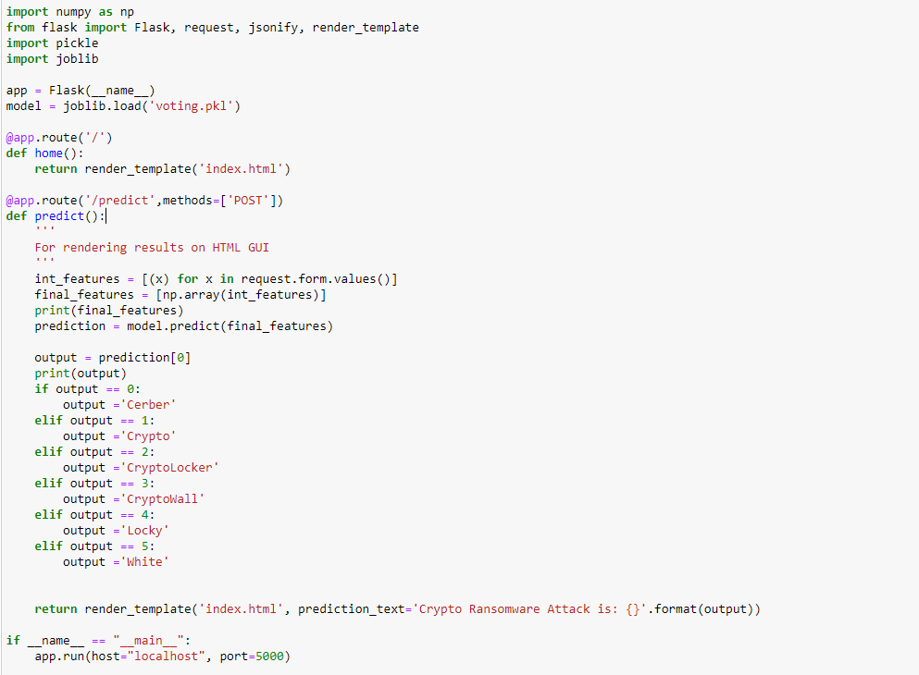

**Fig A.1 Deployment using Flask (Web Framework)**



**Fig A.2 Input Webpage**



**Fig A.3 Predicted Attack – Montreal CryptoXXX**



**Fig A.4 Predicted Attack - Montreal CryptoLocker**



**Fig A.5 Predicted Attack – Padua CryptoWall**



**Fig A.6 Predicted Attack – Princeton Cerber**



**Fig A.7 Predicted Attack – Princeton Locky**



**Fig A.8 Predicted Attack - White**

**REFERENCES**

**[1]** Chadi Assi, Elias Bou-harb, Khaled Sarieddine, Nizar Bouguila Ricardo Misael Ayala Molina, Sadegh Torabi. (2022) **‘On Ransomware Family Attribution Using Pre-attack Paranoia Activities’**,IEEE Transactions On Network And Service Management, Vol. 19, No. 1, March 2022.

**[2]** Suleiman Ali Alsaif. (2022) **‘Machine Learning-based Ransomware Classification Of Bitcoin Transactions’**,Applied Computational Intelligence And Soft Computing, Vol. 2022; Article ID 6274260.

**[3]** A. Cartwright and E. Cartwright, J. Hernandez-castro. (2022) **‘An Economic Analysis Of Ransomware And Its Welfare Consequences’**,Royal Society Open Science, Vol. 07, Issue 3, March 2022; https://doi.org/10.1098/rsos.190023

**[4]** Hardi Sabah, Hezha M.TAREQ Abdulhadi, Talabani. (2022) **‘Bitcoin Ransomware Detection Employing Rule Based Algorithms’**, Science Journal Of University Of Zakho, Vol. 10, No. 1: January - March Issue; https://doi.org/10.25271/Sjuoz.2022.10.1.865.

**[5]** Abdullah Alqahtani, Frederick T. Sheldon. (2022) **‘A Survey of Crypto Ransomware Attack Detection Methodologies: An Evolving Outlook’**, MDPI Open Access Journals, Vol. 22, Sensors, 22(5), 1837; <https://doi.org/10.3390/s22051837>.

**[6]** Sabira Karim, Shemitha PA. (2021) **‘A Survey on Detection and Classification of Ransomware Bitcoin Transactions’**, IJARIIE-ISSN(O)-2395-4396, Vol. 07, Issue 3, 2021.

**[7]** P.V. Lakshmi, Vytarani Mathane. (2021) **‘Predictive Analysis of Ransomware Attacks using Context-aware AI in IoT Systems’**, (IJACSA) International Journal of Advanced Computer Science and Applications, Vol. 12, No. 4, 2021.

**[8]** Micheline Al Harrack. (2021) **‘The BitcoinHeist: Classifications of Ransomware Crime Families’**,International Journal of Computer Science & Information Technology (IJCSIT), Vol. 13, No. 5, October 2021.

**[9]** Kirat Jadhav. (2020) **‘Investigating Machine Learning Approaches for Bitcoin Ransomware Payment Detection System’,** ISSN No:-2456-2165, Vol. 05, Issue 9, September – 2020.

**[10]** Jason E. Thomas. (2018) **‘Individual Cyber Security: Empowering Employees to Resist Spear Phishing to Prevent Identity Theft and Ransomware Attacks’**,International Journal of Business Management, 12(3). 1-23; doi:10.5539/ijbm.v13n6p1.

**[11]** Anup Girdhar, Navneet Kaur Popli. (2018) **‘Behavioural Analysis of Recent Ransomwares and Prediction of Future Attacks by Polymorphic and Metamorphic Ransomware’**, Computational Intelligence: Theories, Applications and Future Direction,Part of the Advances in Intelligent Systems and Computing book series (AISC, Volume 799);10.1007/978-981-13-1135-2_6